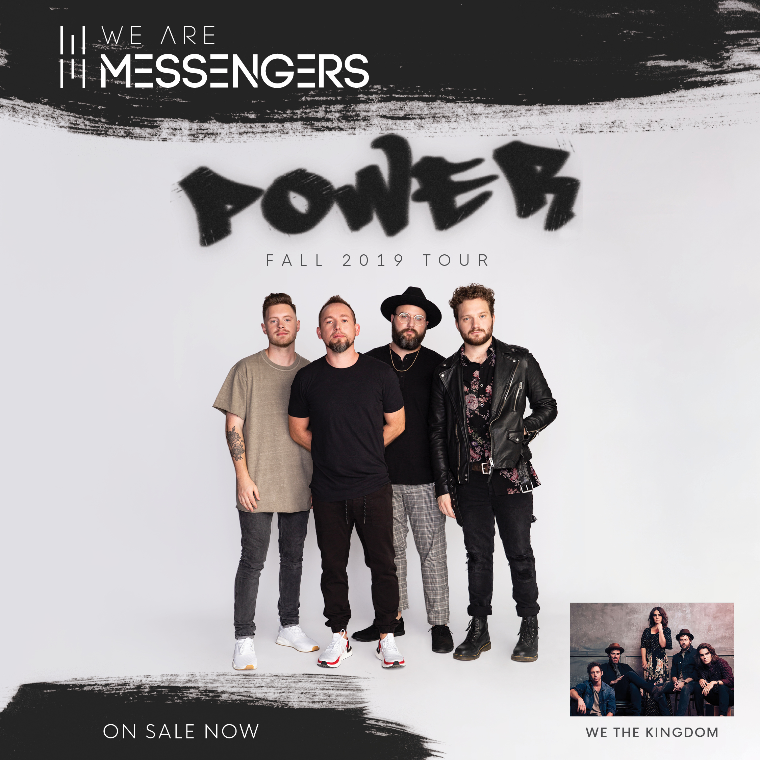
Subject Line: We Are Messengers Power Tour Coming To Your City

We are excited to announce that Pre-Born! and WAM
are partnering together to bring you the
We Are Messengers Power Tour

Pre-Born! is partnering with WAM to bring more funding and resources to our clinic through the following opportunities:
- A percentage of the tickets sold for the concert goes entirely to our clinic.
- Our clinic can set up promotional materials in the Pre-Born! booth at the concert in order to obtain volunteers for our clinic and gain FREE exposure in our community, which could potentially bring more funding to our clinic.

Please prayerfully consider purchasing tickets for the concert on _____________ at_________.
Pre-Born! is a grant provider and works directly with pregnancy resource clinics. Their mission it to glorify Jesus Christ by leading and equipping pregnancy clinics to save more babies and souls.
To purchase tickets, visit preborn.com/we-are-messengers. Enter code PREBORN for a discount on your ticket.

